/*Write a program in C language to read two numbers A and B and to calculate addition in C and Print it */
/*Name :- Ashish Doneriya*/
/*Scholar No. 101112011*/

#include<stdio.h>
#include<conio.h>
void main()
{
int A,B,C;
clrscr();
printf(This program is to read 2 no. A & B & to calculate addition & Print it\n);
printf(“Reading values of Input\n”);
printf("Enter value of A and B : ");
scanf("%d %d",&A,&B);
printf(Calculating sum of given numbers\n);
C=A+B;
printf(Printing the result\n);
printf("Sum of %d and %d is %d",A,B,C);
getch();
}
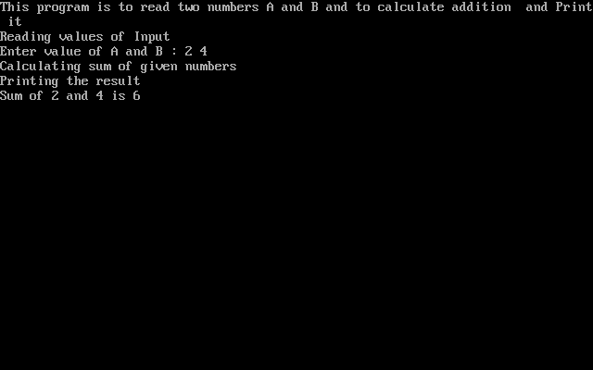
OUTPUT

